Welsh Junior Inter Club Championship
Wednesday 31st October – Builth Wells Golf Club

Builth Wells Golf Club Junior Team was crowned 2018 Welsh Junior Inter Club Champions with a 7 shot winning margin on 31st October.

6 teams took part representing Pyle & Kenfig, Creigiau, St Pierre, Carmarthen, Builth Wells and Abergele Golf Clubs with the competition format being 18 hole medal off handicap, with the best gross score plus 4 best net scores counting from the team of 6.

Builth Wells team of Zak Baker, Aaron Evans, Grace Edwards, Ciaran Price, Tom Offa, Ruben Edwards and reserves Thomas Edwards and Ceri Jones, totaled a score of 333 to beat Carmarthen into 2nd place that scored 340.

This is the first time in the history of the event that Builth Wells Golf Club has won the trophy and following the win have been invited to represent Wales in the Home Nations Cup Final in Portugal from 23rd – 29th January 2019, where they will play against teams from England, Ireland and Scotland.

The hard work starts now as unfortunately the event in Portugal is part subsidised, primarily SELF funding; therefore any donations/sponsorship would be very gratefully received. Brecon & Radnor County Golf Union very kindly donated £1,000 from the legacy left when Summerhill Golf Club closed a few years ago, this will go a long way to sending the squad of 8 players to Portugal, however more is needed to cover flights etc.
If anyone would like to donate/sponsor the squad please contact Simon Edwards on 01982 553296 or info@builthwellsgolf.co.uk.

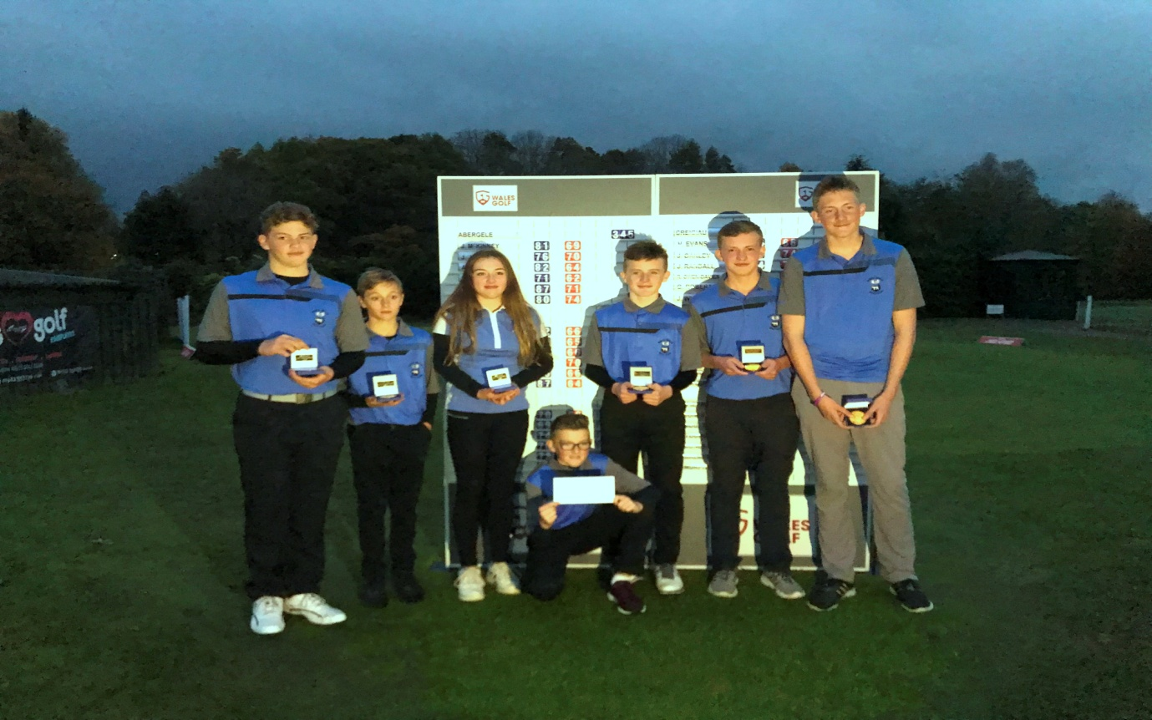

(Missing from picture Ceri Jones)

